**CameraMotionBlur**

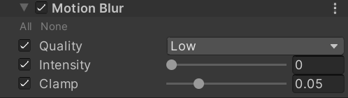

Quality

The quality of the effect. Lower presets will result in better performance at the expense of visual quality.

Intensity

The strength of the motion blur filter. Acts as a multiplier for velocities.

Clamp

Sets the maximum length, as a fraction of the screen's full resolution, that the velocity resulting from Camera rotation can have. Lower values will improve performance.

How:

1. 计算运动方向
   1. 根据屏幕UV计算出世界坐标；
   2. 根据根据记录的前一帧矩阵信息就算出上一帧的clipPos；
   3. 两个clipPos计算差值。
2. 沿着运动方向进行模糊